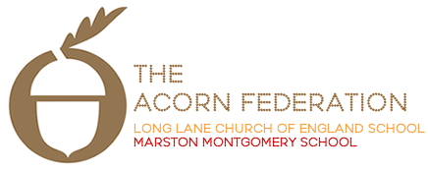

Meadow Class

Theme Leaflet

Spring Term 2023

English
Spring 3:
Who Let the Gods Out - Maz Evans
Yrs 3 and 4: Fact-sheet
Yrs 5 and 6: Report (Gods)
Spring 4:
Willow Pattern Story (Traditional Chinese)
Traditional Story, Poetry
Mathematics
Number, Addition and Subtraction, Fractions, Measurement, Geometry, Multiplication,
Science
Spring 3 and 4:
Yr 3 and 4: Sound
Yr 5 and 6: Earth and Space
Religious Education
Spring 3: U2.4 If God is everywhere, why go to a place of worship?
Spring 4: U2.1 Why do some people believe in God and some people not?
Art and Design
Spring 3:
Working with Shape and Colour “Painting with Scissors” Collage and Stencil in response to Artwork
Computing
Spring 3: Digital Writing and Presentations
Design and Technology (Spring 4)
TBC
Geography
Eastern Europe - Russia
History
How Britain changed from the Bronze Age to the Iron Age
Languages
Où habites-tu ?
Music
Spring 3: A New Year Carol
Spring 4: You’ve Got a Friend
Outdoor Learning
N/A
Personal, Social and Health Education
Difference and Diversity
RSE
N/A
Physical Education
Dance, Tag Rugby and Multiskills

Dates for this term

