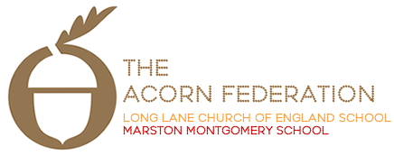

Meadow Class

Theme Leaflet

Spring Term 2022

English
The Railway Children – Narrative/Newspaper Reports
Clockwork – Philip Pullman – Biography (Inventors)
Mathematics
Years 3 and 4: Multiplication and Division, Measurement, Fractions, Decimals.
Years 5 and 6: Fractions, Decimals, Percentages, Measures, Algebra, Area, Ratio, Presenting Data.
Science
Years 3 and 4: States of Matter
Years 5 and 6: Properties and Changes to Materials
Religious Education
Spr 1: What Would Jesus Do?
Spr 2: What Do Christians Believe Jesus did to Save Them?
Art and Design
Rose and Castle Canal Art (Stencil work)
Computing
Web Page Creation.
Design and Technology
Musical Instruments
Geography
Map-work
History
Transport – Canals and Railways
Languages
À Table – Food and Eating
Music
Flute Playing and Performing
Personal, Social and Health Education
Spr 1: Being Responsible Spr 2: Money Matters
Physical Education
Spr 1: Tag Rugby/Multi-Skills Spr 2: Netball/Tennis

