PE Funding

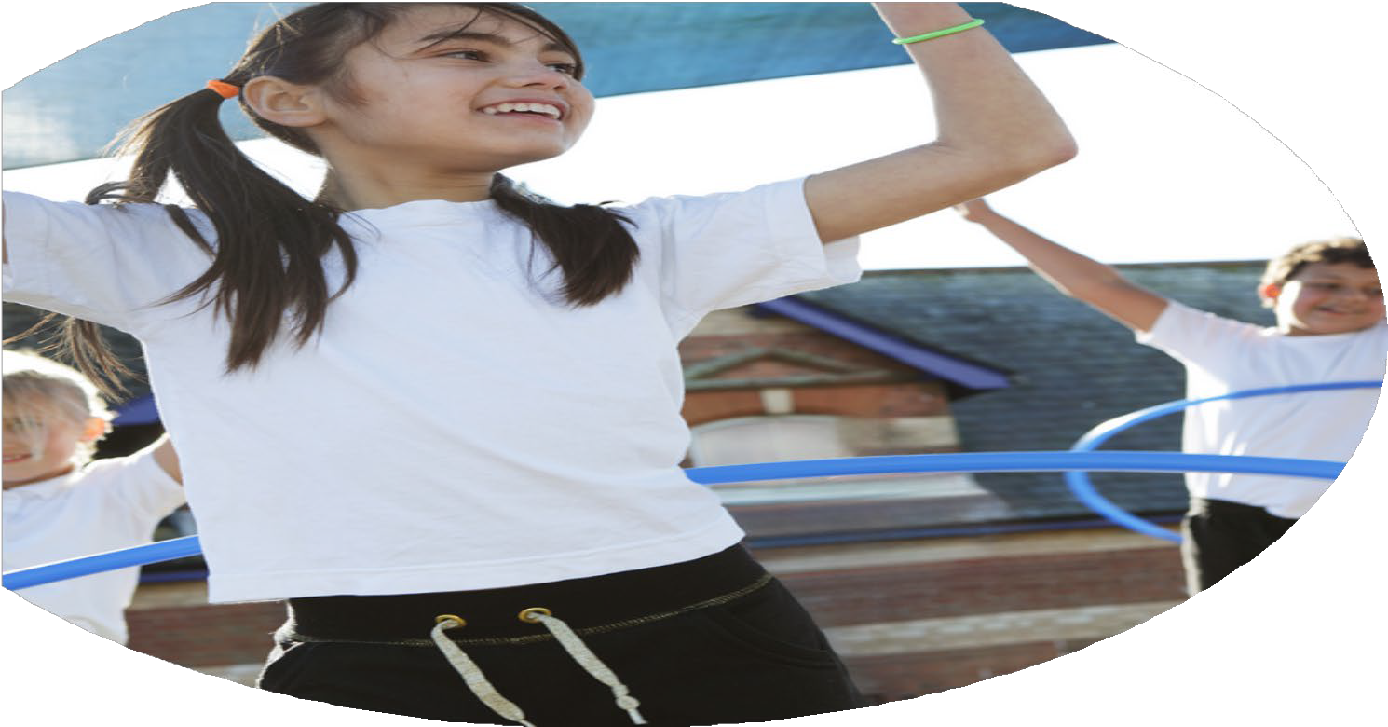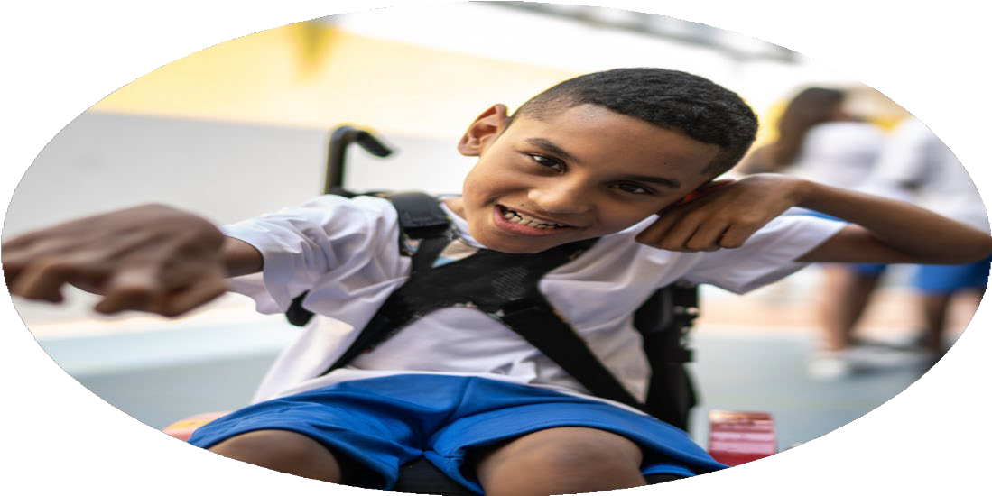

Evaluation Form

**Commissioned by**

**Created by**

Images courtesy of Youth Sport Trust

**PE Funding Evaluation Form**

 It is intended that this template should be used as preparation for the completion of the statutory digital reporting tool being introduced this academic year. You can upload data (including swimming) from this template onto this platform once it becomes accessible.

 Before you decide how you are going to use the funding for this academic year you should reflect and evaluate the impact of your use of the funding in 2023/24.

 All spending of the funding must conform with the terms outlined in the Conditions of Grant document.  The template is a working document that you can amend/update during the year.

 Based on your evaluation of last year’s funding you should decide what you intend to do this academic year, how you will do it, and what impact you expect it to have.

It is important that the funding is used effectively and based on your school’s needs.

 You must use the funding to make additional and sustainable improvements to the PE and sport in your school.  You must develop and add to the PESSPA activities that your school already offers.

*Summative digital reporting from June 2025 will continue to include swimming and water safety information therefore funding can be used to provide top-up lessons where necessary to ensure pupils meet national curriculum swimming requirements.*

**We recommend that you start by reflecting on the impact of current provision and reviewing your previous spend**

|  |  |  |  |
| --- | --- | --- | --- |
| What went well? | How do you know? | What didn’t go well? | How do you know? |
| * Children engaged in lots of sporting activities. * Children took up sports outside of school. | * We attended events and had providers come in to showcase new activities. * Children joined clubs outside of school | * We were unable to attend any activities affiliated with the local secondary school due to staffing. * We didn’t make the bronze school games mark. | * We couldn’t go to the events. * We did not quite meet the criteria. |

|  |  |
| --- | --- |
| What are your plans for 2024/25? | How are you going to action and achieve these plans? |
| Intent | Implementation |
| * To continue to introduce new sports aside from the curriculum to the children. * To attain the bronze school games mark. * To make better links with the local secondary school. | * Keep using outside providers who enhance our sports provision. * Follow the criteria and ensure targets are met. * The staffing shouldn’t be an issue this year. |

|  |  |
| --- | --- |
| What impact/intended impact/sustainability are you  expecting? | How will you know? What **evidence** do you have or  expect to have? |
| * Children to be exercising actively more. * Children to be exposed to different sporting activities, broadening their skill sets. * To ensure children continue to benefit from intra school tournaments as we are so small these are a real benefit. | * Time will show. * I have picked sporting enrichment days outside our curriculum. * By attending events and building those links and children’s resilience. |

|  |  |
| --- | --- |
| What **impact/sustainability** have you seen? | What **evidence** do you have? |
| * Teachers and Learning Assistants have had consistent CPD from outside providers. * Children (due to attending events) have then joined clubs outside of school. * Children have had the chance to compete against their peers in bigger numbers. | * Teachers and Learning Assistants more confident in delivering content. * Children have told us about their achievements. * We have attended events and seen children s confidence grow competing against their peers. |